Schmitt Triggers

A control system is used to compress air in a workshop for use with air driven machine tools.
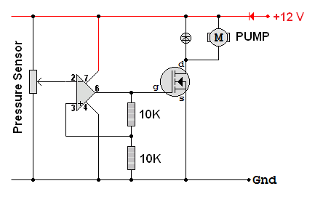
As the air pressure increases, the output voltage from the sensor rises.

1) a) Calculate the upper switching level of this circuit.
1) b) Calculate the lower switching level of this circuit.
1) c) In what circuit configuration is the operational amplifier wired?

1) d) Is this closed or open loop? Explain your answer.

1) f) Explain how this circuit works.
1) g) Use the graph below to estimate the highest working pressure reached by this control system.

1) h) Use the graph below to estimate the lowest working pressure reached by this control system.
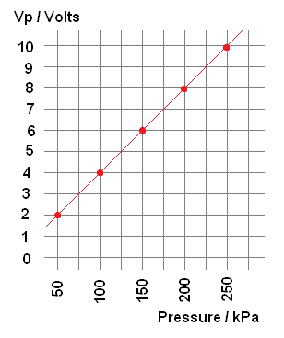
1) i) Why is the diode needed? How does it work?

