Name
- Write down 47kΩ in engineering notation ( 4.7 x 10^{x} )
- Write down 4.7MΩ in engineering notation ( 4.7 x 10^{x} )
- Write down 47mΩ in engineering notation ( 4.7 x 10^{x} )
- Write down the Voltage Divider formula.
- Calculate the output voltage for the circuit below. FNAU !!!!
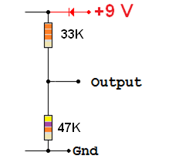
- Explain how a comparator works.
- A 10K resistor is in parallel with a 22K resistor. Calculate the combined resistance. FNAU !!!!
- Explain two features that differ between a Schmitt trigger and a comparator circuit.

- a) At high temperatures, is the output high or low?
b) What is the thermistor resistance at the change-over temperature?
c) What is the change-over temperature?
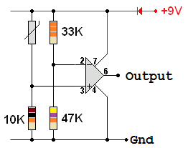
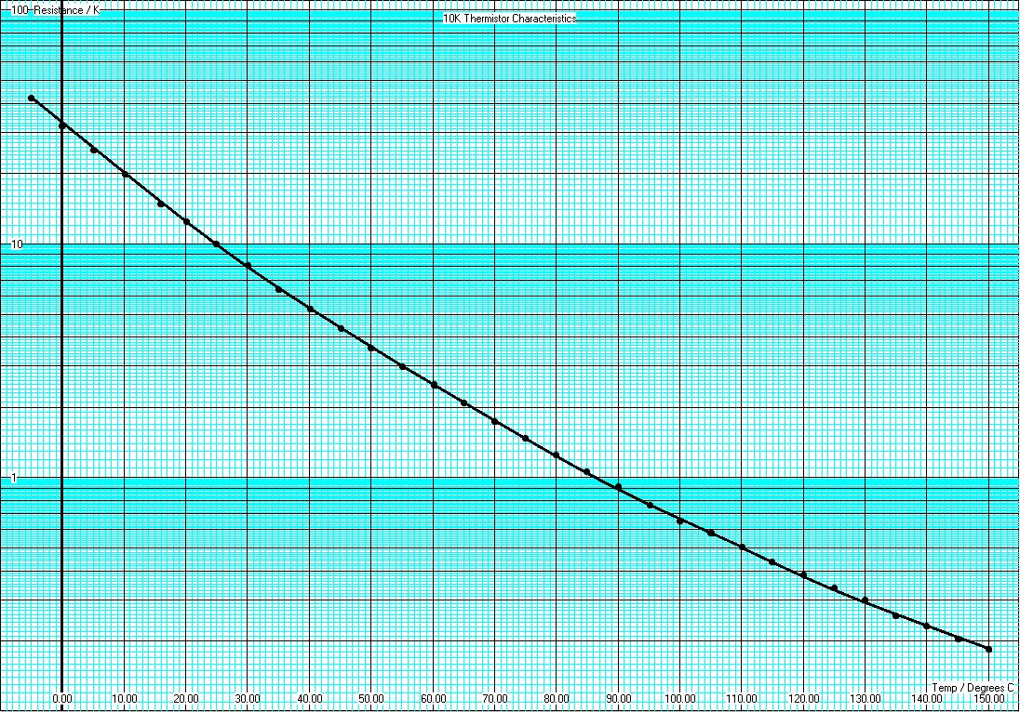
d) Add a resistor to the diagram above to convert the comparator into a Schmitt Trigger.
e) What type of feedback does this resistor provide?
f) At 25 degrees C, what is the thermistor resistance?
g) At 145 degrees C, what is the thermistor resistance?

