Touch Switch Page 16.2

A Touch Sensitive Switch

- Light an LED with current flowing through your finger!
- You'd need 10 mA. This is a potentially fatal current although your skin resistance would limit this current!
- Instead use bipolar transistors as current amplifiers.
- The BC182L amplifies the Base current about 200 to 300 times.
- Now a minute current through your finger can turn on the LED.

Bipolar Transistor Switch
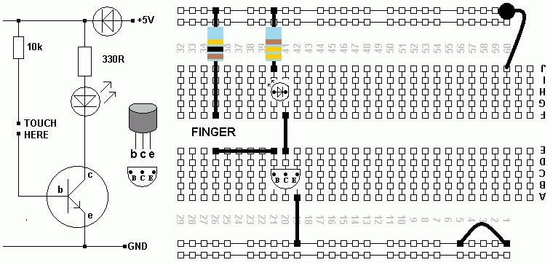

Build this circuit. Use your fingers to bridge the gap as shown. The LED might light dimly. If you have sweaty fingers, it might be brighter.

Darlington Switch
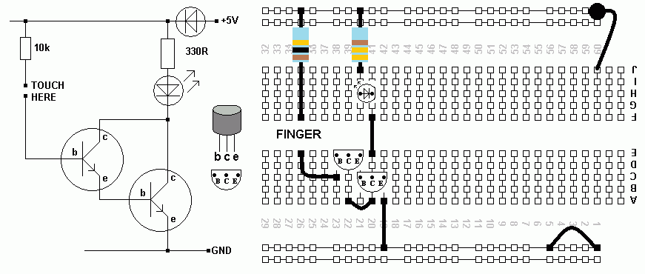

This uses two transistors so the current multiplying effect is much greater. So great in fact that just touching the base connection without completing the circuit is enough to light the LED. Your body is acting as an antenna and picking up all the electrical noise in the room. This is sufficient to light the LED.

