Darlington Driver Chip Page 17

Used with the LED Bar
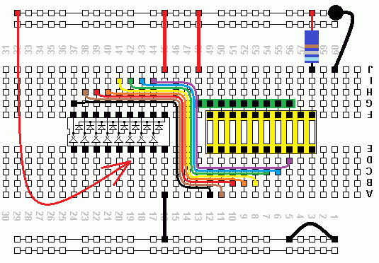
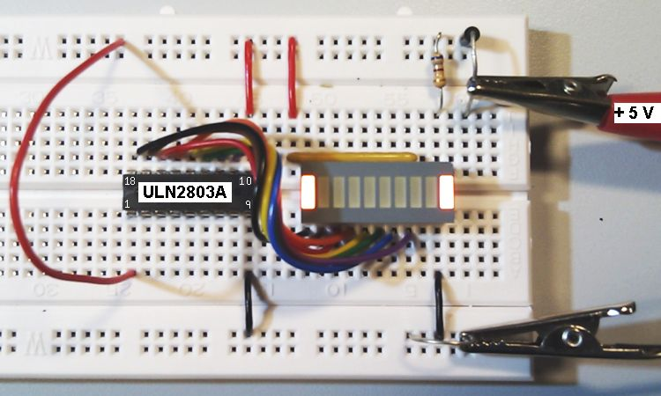
The LEDs are in a Dual in-line (DIL) integrated package.
The eight resistors are in a Single in-line (SIL) integrated package.
The discrete component diode is for polarity protection.
The ULN2803A is an 18 pin DIL integrated circuit (IC).

