MOSFETs Page 20

Metal–oxide–semiconductor field-effect transistor
A small voltage and an extremely small current control a much larger current up to several amps for a power MOSFET.

Properties
- Very high (near infinite) input resistance.
- Very fast switching.
- Low output resistance.
- Able to switch large currents (up to nine amps with a power MOSFET and a heat sink).
- Zero volts on the gate will turn the switch off.
- Two to five Volts on the gate (depending on the MOSFET) are needed to saturate the MOSFET (turn it on fully).
- Low drain voltage when saturated (0.1 Volts).

Switch Circuits
This is another touch switch circuit. As the input current is so tiny, it works with one MOSFET.
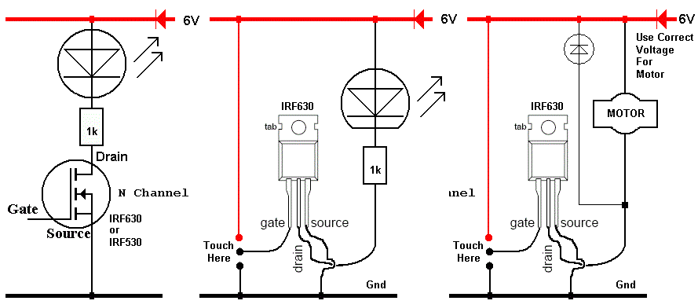

Possible Layouts
