Ideal Operational Amplifier Properties 23

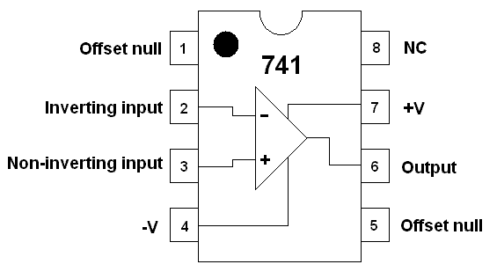
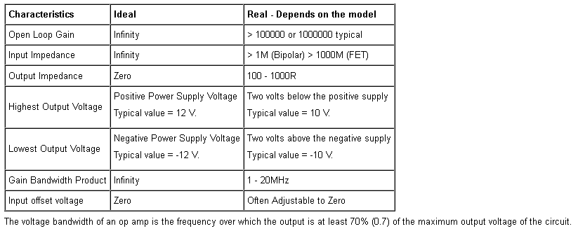

Clipping or Limiting
- An ideal op amp could provide an infinite output voltage range.
- A very good op amp could provide outputs at least up to the power supply voltages.
- Most op amps fall short by about two volts so with a 12 volt supply, the output would be only ten volts.
- The output should be directly proportional to the input. That is perfectly linear.
The image below shows ideal (black) and non-ideal (red and blue) behaviour including clipping when the op amp is saturated and the output voltage can go no higher.
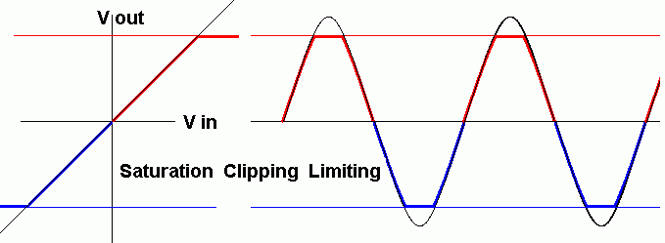

Gain Bandwidth Product(GBP)

Gain x Frequency = GBP
The gain is calculated or measured from Vout / Vin
The bandwidth is the frequency at which you wish to find the gain.
The gain bandwidth product (GBP) is given in the device data sheet (or exam question).
Gain Bandwidth Product Example
Assume an amplifier has a gain-bandwidth-product of one million. Find the gain for a signal of 2000 Hz ...
Gain x 2000 = 1000000 so Gain = 1000000 / 2000 = 500.

