DC RC Timing Page 27

Two parallel plates insulated from each other. Many capacitors have this structure rolled up into a tube to save space.
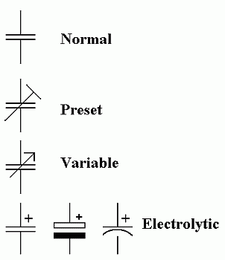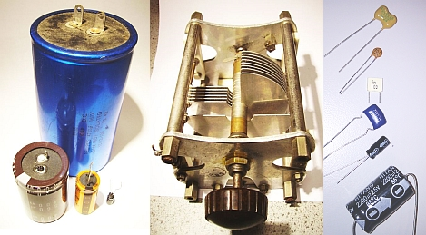
- It takes time to fill the tank / charge the capacitor
- The tank/capacitor fills fast at first and the fill rate slows down, the fuller it gets
- The tank/capacitor empties fast at first and the emptying rate slows down, the emptier it gets
- Eventually the battery/reservoir would be drained
- The water level/capacitor charge can not change suddenly
- If there were more pressure/voltage, the tank/capacitor would fill faster
- The tank fills until the water levels are equal. The capacitor charges until the voltages are equal.

Capacitor Properties
The main characteristics or properties of capacitors are ...
- Capacitance is measured in Farads or more often pico, nano or microfarads.
- One Farad is an enormous capacitance and rarely found in real life.
- Capacitors store energy in the form of a stored electric charge.
- Charge is measured in Coulombs.
- Energy is measured in Joules.
  - Q = CV where
  - Q is the charge,
  - C is the capacitance and
  - V is the potential difference across the capacitor
  - If you double the voltage, the stored charge will double.
- E = CV² / 2 where
  - E is the energy stored,
  - C is the capacitance and
  - V is the potential difference across the capacitor
  - If you double the voltage, the energy stored increases by 22 (four times)
- capacitors block direct current (DC)
- capacitors pass alternating current (AC)
- The breakdown voltage (in Volts). The voltage across the capacitor should never exceed this.
- The upper useful frequency properties.
- The DC leakage current (a particular problem with electrolytic capacitors).

Uses of Capacitors
- Timing
  - R C timing circuits use a resistor and a capacitor for timing purposes.
  - The capacitor charges through the resistor.
  - A bigger resistor will make the capacitor take longer to charge.
  - Also a bigger capacitor will take longer to charge.
- Coupling
  - Also known as a DC blocking capacitor.
  - Couple an AC signal from one subsystem to the next.
  - Prevent DC potentials from being coupled from one subsystem to the next.
- Decoupling
  - Remove unwanted AC signals from the circuit.
  - The capacitor is connected to ground and any AC signals are passed straight to ground.
- Smoothing
  - DC power supplies produce lumpy DC.
  - The smoothing capacitor stores enough charge to smooth out the lumps.
  - Smoothing capacitors are often very big.
- Filtering
  - This is an A2 topic but many AS projects need to take this into consideration.
  - Since capacitors pass high frequencies and block low ones and DC, they can be used to filter low or high frequencies.
  - Capacitors can be wired up to couple (pass) or decouple (block) higher frequencies.
- Tuning
  - When combined with an inductor, a tuned circuit is formed.
  - This is used in radio tuning to select the wanted signal and reject others.

Electrolytic Capacitors
Electrolytic capacitors use thin rolled up foil plates separated by a liquid or gel electrolyte. The insulation between the plates relies on a chemical reaction. If the capacitor is connected up the wrong way round, this chemistry fails and the capacitor works as a conductor instead. It gets hot and can explode!
- Electrolytic capacitors have a very large capacitance for their size
- The breakdown voltage is low. 12 to 160 volt ratings are common
- They have a significant DC leakage current, sufficient to upset some timing circuits
- They are not manufactured with good tolerance / accuracy and this can be up to 50% out
- Their capacitance is not stable and can change with time
- They are not suitable for high frequency radio applications because the coiled up foil roll acts as an inductor blocking high frequency performance
- They work well at audio and ultrasonic frequencies.
Their uses include ...
- DC power supply smoothing - This is a particular example of decoupling.
- Audio signal coupling - Block DC and pass AC.
- Audio signal decoupling - Remove unwanted AC signals.
- Timing in 555 or other timer circuits - RC resistor capacitor circuit
They can not be used ...
- In AC circuits where the polarity across the capacitor reverses
- In logic gate astable circuits because the polarity across the capacitor reverses

