Relaxation Oscillator Page 29
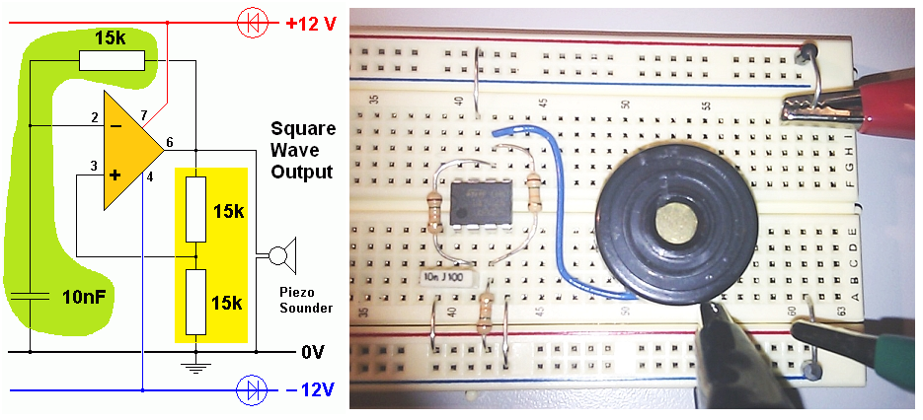

Voltage Divider
The two resistors (yellow) make a voltage divider.
As the resistors are equal, the output voltage is half the input.
The output voltage is fed to the non-inverting op’ amp’ input.

Timing Circuit
The capacitor and third resistor (green) form a timing circuit.
The capacitor charges and discharges through the resistor.
The output voltage is connected to the inverting op’ amp’ input.

Comparator
The Op’ Amp’ compares the timing circuit output with the voltage divider output.
The capacitor charges towards 12 V. When it reaches 6V, the output goes low.
The capacitor discharges towards -12 V. When it reaches -6V, the output goes high again.

Piezoelectric Sounder
This is made from a piezoelectric material that bends when a voltage is applied across it.
The op’ amp’ output voltage switches between +12 and -12 volts very quickly.
This makes the piezoelectric material vibrate and sound waves are produced.

Build the circuit and get it working.

Replace the 15K timing resistor with an LDR.

Shade the LDR to get a different oscillation frequency.

See if you can play a tune!

Measure the output wave shapes using one of the picoscopes.

Use the picoscope to measure the period of the wave from your oscillator.

Calculate the frequency. Frequency = 1 / Period

