LM386 Power Amplifier Page 32

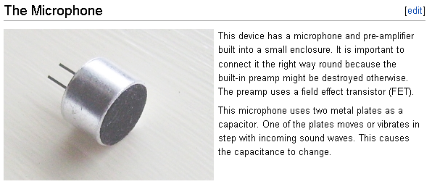
Q = CV The charge Q does not have time to change so, if C changes then V changes by the same proportion.

