Combinational Logic Page 35
Logic Circuits – Build these in the Falstad Simulator
http://www.falstad.com/circuit/index.html
1 | 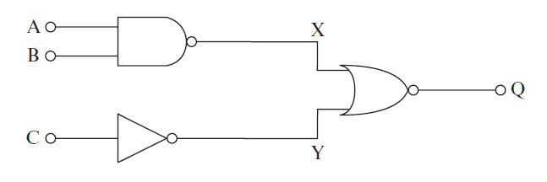  Complete the truth table.  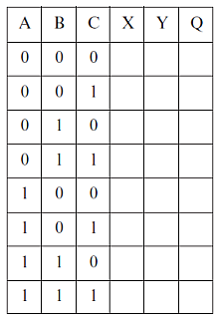
2 | Build the circuit that matches this logic expression.  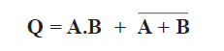  Create a truth table similar to the one above.
3 | Build the circuit that matches this logic expression.  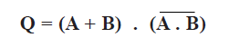  Create a truth table similar to the one above.
4 | Build this in the simulator and complete the truth table.  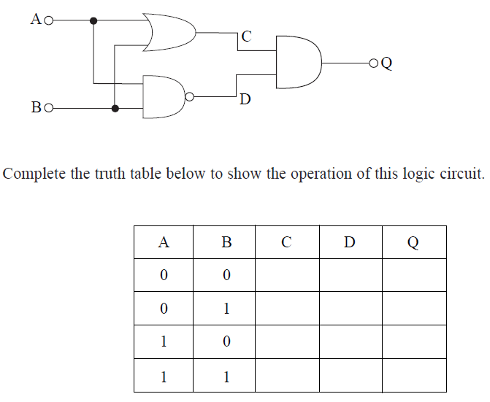

5 | Use the simulator to build a circuit to solve this truth table.  Copy the circuit into the space below.  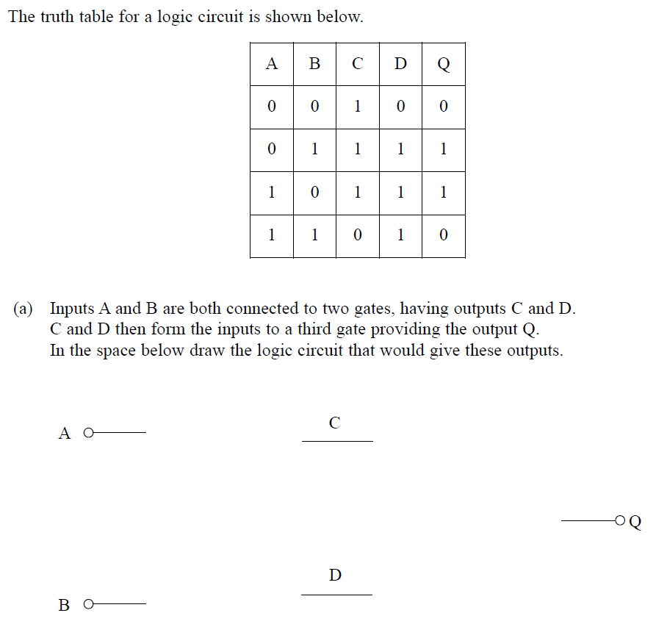
6 | Build this in the simulator  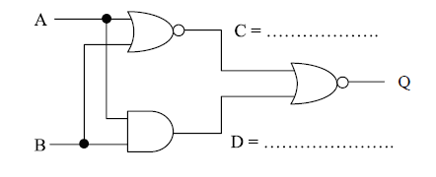  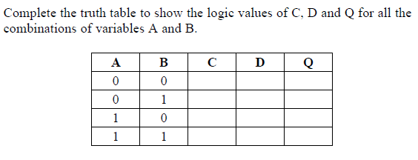

7 | Use the simulator to build a circuit to solve this truth table.  Copy the circuit into the space below.  