4017 with OR Page 37

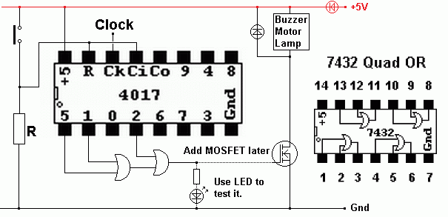
This shows how OR gates can be used to control an event such as a buzz which repeats at specified time intervals.
A MOSFET driver is needed between the OR gates and the buzzer or other device.
Use a 7432 quad OR chip. This runs on 5 Volts so the rest of the circuit should also be run on 5V.

