4013 D Type Flip Flop Page 38.1
- On the rising edge of the clock pulse, the input D is copied to the output Q.
- This is called edge triggered. If the DATA input changes between clock pulses, this has no effect on the output.
- The rising edge of the clock pulse stores the input bit so this flip flop can be used as a data latch (memory).
- A single D Type Flip Flop can store one bit.
- On the rising edge of the clock pulse, if Q = 1 the circuit is "SET". If Q = 0 the circuit is "RESET".
Here is the symbol of a D Type Flip Flop.
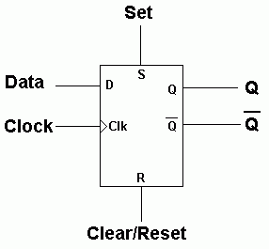 | 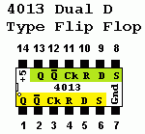

- The device can be set or reset at any time by setting the S or R inputs high.
- This applies to AQA exam questions and 4000 series gates.

Data Latch
Store bits of data on the rising edge of the clock pulse.
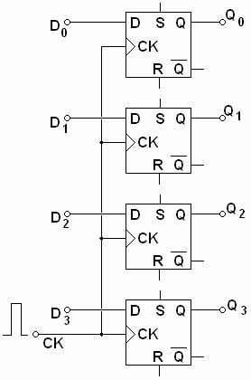 | - On the rising edge of the clock pulse, the data on D0, D1, D2 and D3 is copied to Q0, Q1, Q2 and Q3.  - Data latches are needed to store data that is only available or valid for a short time.  - For example data from the parallel port may not be valid for long.  - If this data is latched (stored), the latch output remains available for as long as necessary.  - The data remains valid until the next clock pulse.

Frequency Divider
On the rising edge of the clock pulse, D is copied to Q.
Since NOT Q is connected to D, the data is inverted on each rising edge.
This has the effect of dividing the frequency by two.
- The D Type Flip Flop is used in Binary Counters.
- Here is the circuit for a one bit counter.
- This can also be used as a frequency divider. It divides the frequency by two.
- The UP in Up Counter is because the counter counts normally with increasing numbers 0, 1, 2, 3 etc.
- The output of this circuit is high for 50% of the time and low for 50% of the time.
- This is a 1:1 mark space ratio.
- This is true whatever the mark space ratio of the clock pulses.
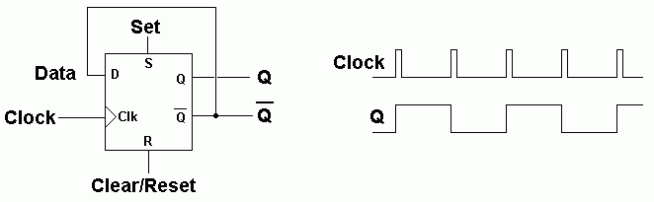

Three Bit Binary Up Counter
This divides the frequency by 8 (or by two three times).
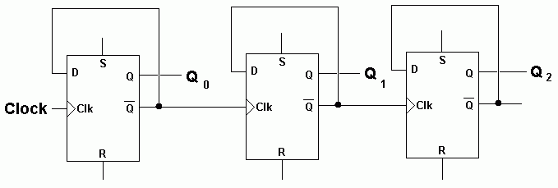
Here is a timing diagram for the three bit counter.
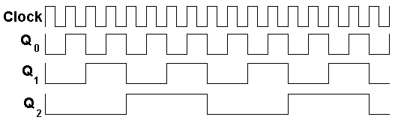

Modulo N Up Counter
This is a counter that resets at a chosen number. For example a two digit decimal counter, left to its own devices will count from 00 to 99. This is not much use for a clock unless you have 100 second minutes. To fix the problem, the counter must go from 00 to 59. This is achieved by detecting a 6 in the left hand digit and using it to reset the counter to zero. This would be a Modulo 6 Counter or 60 if you included both digits.

Modulo 6 Counter - Counts from 0 to 5
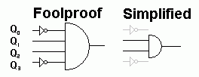
The circuit above detects a six or 0110 in binary. You could use the fool proof circuit but in fact the simpler circuit works too because the 0110 pattern only occurs once between 0 and 9 in decimal numbers. The output is used to reset the counter.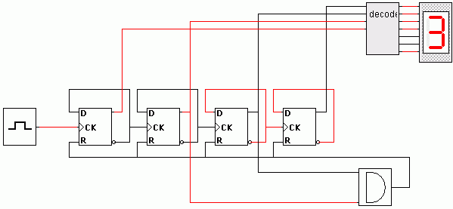
Here is a timing diagram for the modulo 6 counter. It shows the count going from 0 to 5 in regular time steps. The counter reaches 6 but only for about a microsecond before it resets to zero.

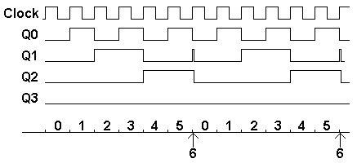

Down Counter
This counter counts down towards zero.
The clock inputs come from the preceding Q instead of NOT Q .
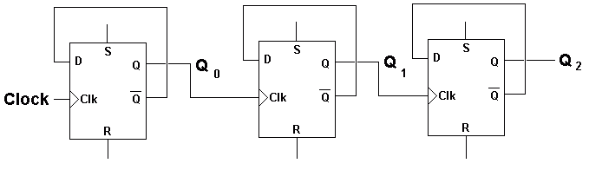

Shift Registers

- On the rising edge of the clock pulse, each D is copied to the next Q.
- The data moves one place to the right along the shift register like suitcases on a conveyor belt.
- Pulses can be delayed using this circuit.
- Shift registers can be used in simple combination locks.
- The registers have to be clocked in the correct sequence to unlock the door.
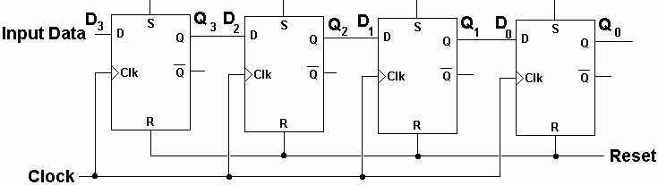

Combinational and Sequential Logic
Combinational Logic: Logic gates but there is No Clock and No Memory
- The output is determined by combinations of one or more inputs.
- There is no clock signal.
- The circuits have no memory.
- The circuits are asynchronous (no clock).
- The output changes immediately when the input changes.

Sequential Logic: Logic gates with a Clock and Memory
- If your circuit has a clock, counters, or D-Type Flip-Flops, it is Sequential Logic.

