Circuit Diagrams

GCSE and AS
- Add and label pull-up and pull-down components to trigger this 555 Monostable.
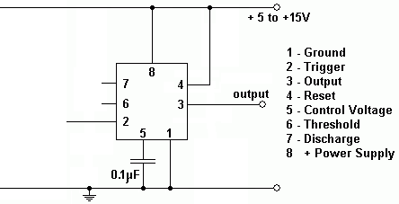
- Add the necessary timing components to the 555 Monostable circuit above.
- Write down the formula for the pulse period of a 555 Monostable.
- Sketch the circuit diagram symbols for a
DIODE:
FUSE:
POTENTIOMETER:
RESISTOR:
THERMISTOR:
LDR:
LED:
ZENER DIODE:
MOSFET n Channel:
BIPOLAR NPN TRANSISTOR:
CAPACITOR:
TUNING CAPACITOR:
- The Driver output is either high or low. Add an LED and any other required components to make the LED light when the driver output is high. Write the word HIGH beside this LED.
- In the circuit above, the Driver output is either high or low. Add an LED and any other required components to make the LED light when the driver output is low. Write the word LOW beside this LED.
- Complete the circuit below for a 555 Astable driving a piezoelectric sounder.
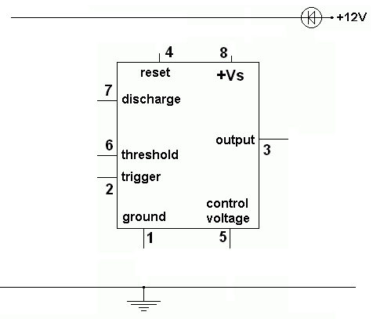
- Name each gate and complete each truth table.
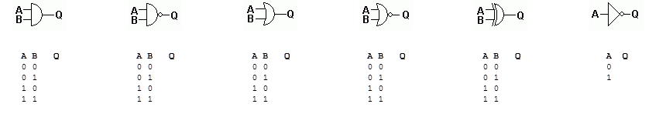
- Draw a diagram of a light sensing comparator. When it gets dark, two LEDs should switch on.
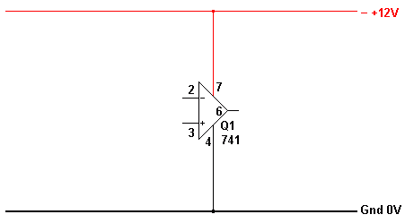
- Add to this diagram to make a four bit latch. Label the four inputs, the four outputs and the clock.
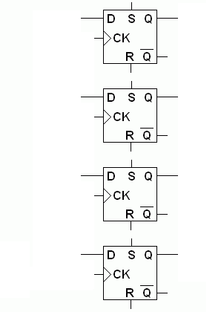

- Add to the D Type Flip Flop diagram to make a circuit that divides the input frequency by two.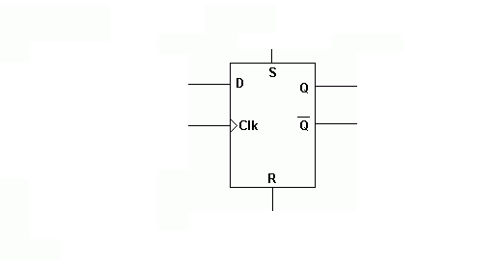
- Complete this diagram showing an N Channel MOSFET switch controlling a motor. Label the three MOSFET pins.
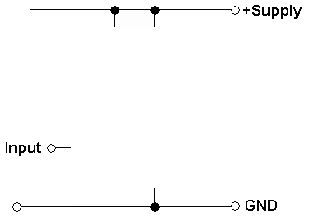

- Complete this diagram showing an NPN Transistor switch controlling a lamp. Label the three transistor pins.
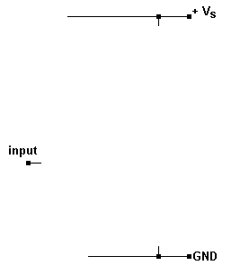

- Draw a circuit diagram showing a battery, an LED and any other required components.
Include an ammeter to measure the current and two voltmeters, one to measure the potential difference across the resistor and the other to measure the potential difference across the LED.
- In the circuit above, the battery voltage is 9.8 V. The LED voltage is 1.8 V. The LED current is 10 mA. Calculate the value of the resistor.
- What E24 resistor would you select for the circuit above?
- What is the colour code of the E24 resistor you selected above? Assume it is a 5% tolerance resistor.
- 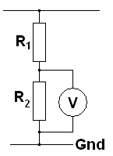
In the circuit above, if R1 = 40 Ohms, R2 = 22 Ohms and the Supply Voltage = 7 Volts, calculate the potential difference across R₂.

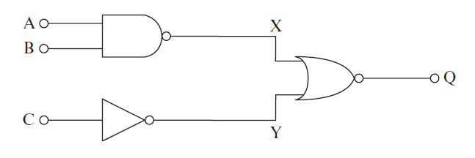
Complete the truth table.

 