ELEC2 Revision

- Draw a circuit diagram for a 555 monostable
- Explain how the 555 Monostable works
If Ra is 100 kΩ and C1 is 4.7 µF, calculate the monostable period.
Answer: 0.517 or 0.52 seconds.
If Ra is 47kΩ, to get a one second pulse, calculate the required capacitor.
Answer 19 µF
- Draw a circuit diagram for a 555 astable
- Explain how the 555 Astable works
- If Ra is 100 kΩ and Rb is 10 kΩ and C1 is 10nF, calculate the pulse high time. 0.77 ms.
If Ra is 100 kΩ and Rb is 10 kΩ and C1 is 10nF, calculate the pulse low time 0.07 ms,
If Ra is 100 kΩ and Rb is 10 kΩ and C1 is 10nF, calculate the output frequency 1200 Hz or 1.2 kHz.
- Draw the circuit diagrams of …
Inverting Amplifier with a gain of -12 – Label the virtual earth – Explain the virtual earth – What is the input resistance? – What is the voltage gain formula?
Non – Inverting Amplifier with a gain of 11 - What is the input resistance? – What is the voltage gain formula?
Summing Amplifier– Label the virtual earth – Explain the virtual earth – What is the input resistance of each input? – What is the formula for Vout? Other than summing, what is a common use for a summing amplifier?
Difference Amplifier with a gain of 1 - What is the input resistance? – What is the formula for Vout? What is a common use for a difference amplifier?
- Draw the symbol for a D Type Flip Flop.
Explain the operation of the D Type Flip Flop.
- Draw the circuit diagram of a three bit binary up-counter which counts from 0 to 5 repeatedly.
Label the clock input. Label the MSB and the LSB outputs.
This is called a modulo ___________ counter.
- Draw the circuit diagram of a push pull MOSFET source follower amplifier without biasing or feedback.
What is the voltage gain of this amplifier? What is the power or current gain?
What is the main problem with this circuit? Sketch an oscilloscope trace showing Vin and Vout for a sine wave signal.
- Draw the circuit diagram of a push pull MOSFET source follower amplifier with biasing but no feedback.
- Draw the circuit diagram of a push pull MOSFET source follower amplifier with biasing and negative feedback.
- When the push switch is depressed, estimate how long it will take for the capacitor to charge fully.
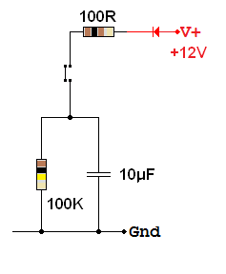
When the push switch is released, estimate how long it will take for the capacitor voltage to drop to 6 volts.
What is the time constant of the charging circuit?
What is the time constant of the discharging circuit?
- If the power supply for this audio amplifier is + / - 12 Volts and the speaker resistance is 8 Ω, assuming ideal components, estimate the output power.
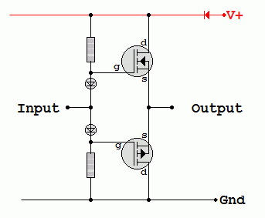
- For the amplifier above, sketch an oscilloscope trace of both the input and the output. The input is a sine wave of 30 volts peak to peak.
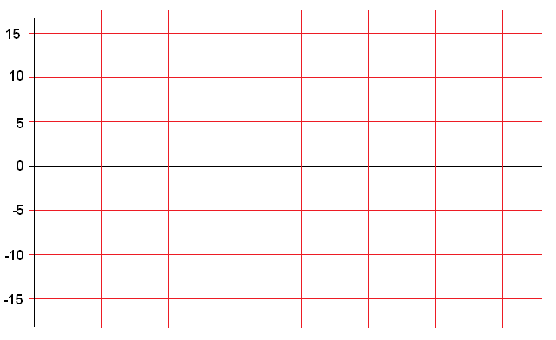
- Draw the circuit diagram of a four stage shift register based on D Type Flip Flops
Explain how this circuit works.
- Add an LED which lights when the output is high and a buzzer which sounds when the output is low.
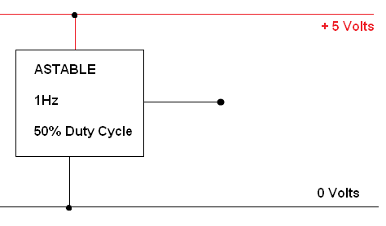
- What is meant by a 50 % duty cycle?
- Draw the circuit diagram of an op-amp voltage follower.
What is its input resistance? What is its voltage gain? Why is it useful?
- Complete this diagram of a Sample and Hold circuit. Label the input and output.
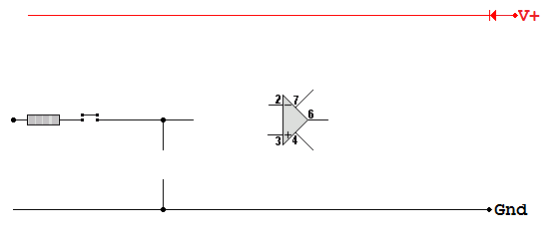
- Define voltage bandwidth.
- An amplifier has a gain bandwidth product of one megahertz. What is the highest possible gain if the amplifier is to have a bandwidth of 20kHz, thus covering all frequencies audible by humans.
Answer: 50.
- Sketch a graph showing the charging of this capacitor from the instant when the switch is closed. The shape should be realistic and the graph drawn accurately based on calculations of the charging time.
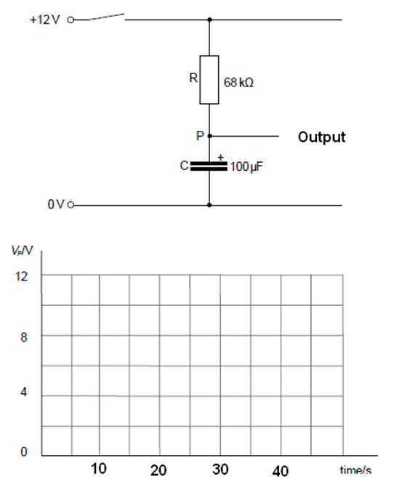
- Complete this diagram. Explain how the circuit operates.
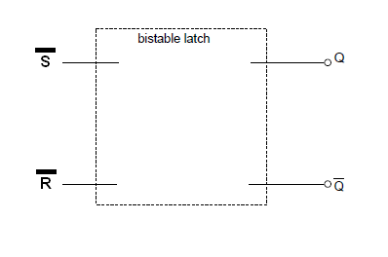
- Draw the circuit diagram for a 4 data bit latch based on D Type Flip Flops. Explain how it works.

