Op Amps - Key Facts
Ideal Op Amp
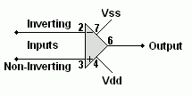
Gain | Infinity
Input resistance | Infinity
Output resistance | Zero
Gain Bandwidth Product (GBP) | Infinity  Gain x Frequency = GBP

Comparator
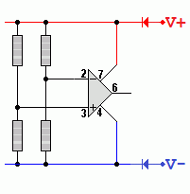
Gain | Infinity
Output | Always saturated high or low
Input Resistance | Infinity
Comparisons | - If V+ is greater than V- then the output is high.  - If V+ is less than V- then the output is low.

Inverting Amplifier
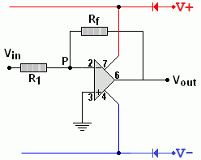
Gain | - Gv = -Rf / R1  - Gv = Vout / Vin
Input resistance | R1
Virtual Earth | Point P  Op Amps have a very high open loop gain so if the output is a few volts, the inverting input voltage will be a few microvolts. This is so close to zero, it is called a virtual earth.

Non Inverting Amplifier - Two Ways to Draw the Diagram
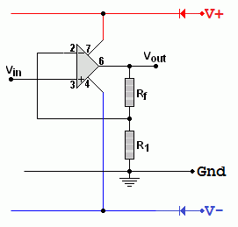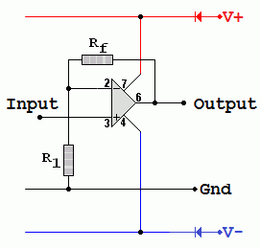
Gain | - Gv = 1 + Rf / R1  - Gv = Vout / Vin
Input resistance | The input resistance of the op amp which is roughly infinity.

Summing Amplifier
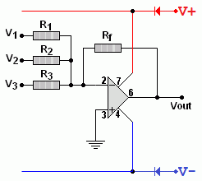
Calculate Vout | Vout = - Rf (V1/R1 + V2/R2 + V3/R3)
Input resistance | It's R1 for the V1 input and R2 for the V2 input etc.
Virtual Earth | The point P is the virtual earth.

Difference Amplifier
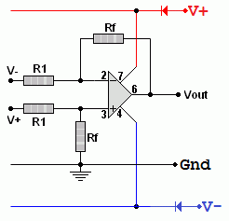
Calculate Vout | Vout = ( V+ - V- ) x ( Rf / R1 )
Input Resistance | 2 x R1

Voltage Follower
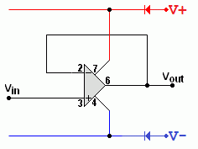
Voltage Gain | The voltage gain is ONE.
Power and Current Gain | This can be very large.
Input resistance | Infinity
Output resistance | Small so usefully large currents can be provided.
Schmitt Trigger
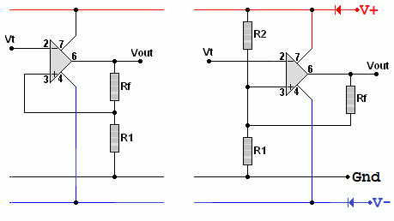
- On the left, a simple version with positive feedback giving different on and off reference voltages.
- On the right is a comparator with one extra resistor giving positive feedback to give different on and off reference voltages.

