Folder Page 7

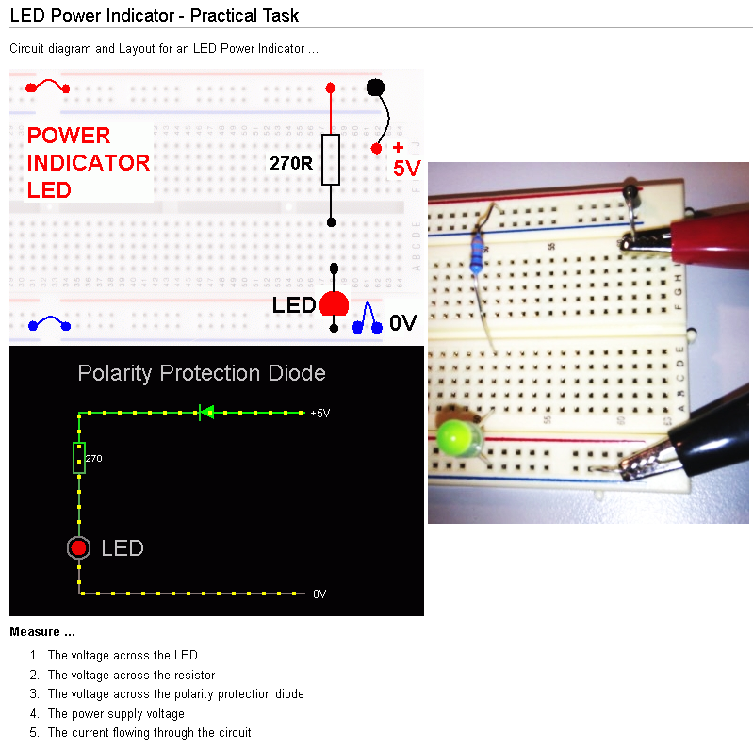

Extra Task if you have time …
Visit this website and build the circuit using the simulator. http://www.falstad.com/circuit/

«First» «Last» - Block: «Block» Folder Page 7.1
