Potentiometer Page 7.2

Specification

Circuit Diagram | 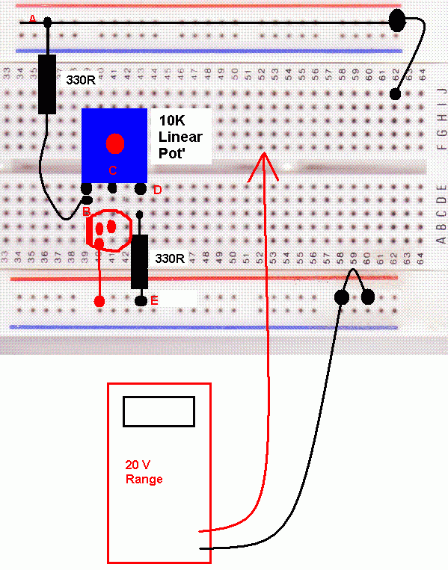
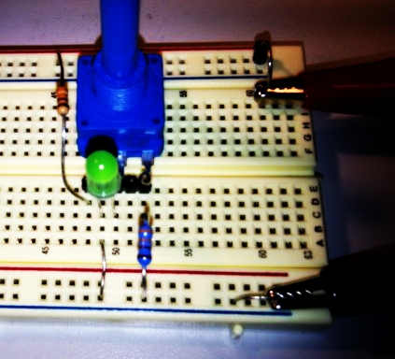 | Measurements  Lowest LED Voltage:  Highest LED Voltage:  Highest Circuit Current:

