Folder 11.1
- What is the potential difference across an ideal ammeter.
- What is the current through an ideal volt meter?
- Write down the Ohm's law formula
Calculate the value of R1.
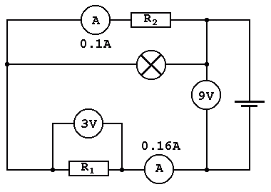
- In this circuit, what is the current flowing through the battery? Give your answer in milliamps.
- What is the battery voltage in the circuit above?
- In the circuit above, what is the current flowing through R₁?
- In the circuit above, what is the current through the lamp?
- In the circuit above, what is the potential difference across R₁?
- In the circuit above, what is the potential difference across R₂?
- In the circuit above, what is the potential difference across the lamp?
- In the circuit above, what is the resistance of the lamp?
- What is the name of the circuit below?
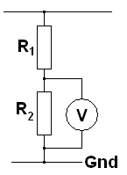
- In the circuit above, if R1 = 40 Ohms, R2 = 22 Ohms and the Supply Voltage = 7 Volts, calculate the potential difference across R₂.

Folder CopyFolder - Block A Folder 11.2
- In the circuit below, if V = 9 Volts, A₁ = 4 amps and A₂ = 1 amp, calculate R₂.
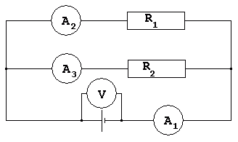
- Write down the resistors in parallel formula.
If a 37 Ohm resistor is in parallel with a 39 Ohm resistor, calculate the overall resistance.
If three resistors are in parallel and their values are 12, 12 and 6 Ohms, calculate the combined resistance.
- The oscilloscope below is set to one volt per division. What is the peak voltage shown on the trace below?
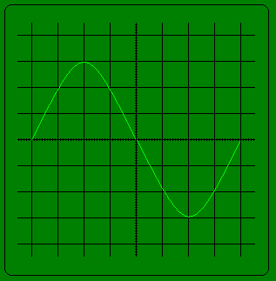
- Use the graph below to estimate the resistance when the temperature is 25C.
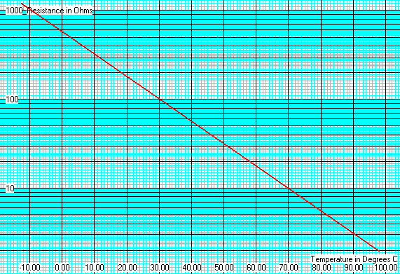
- Use the graph above to estimate the temperature when the resistance is 100 Ohms?
- Use the graph above to find the thermistor resistance at 90C?
- Use the graph above to find the temperature when the resistance is 590 Ohms

