Page 13.1

RESISTORS
- Resistors limit the current flowing to a smaller safe level.
- Two or more resistors can be used as a voltage divider.
- Voltage dividers can use fixed resistors.
- Voltage dividers can use thermistors or LDRs to make temperature or light sensors.
- Voltage dividers can use potentiometers to make angle sensors.
- Voltage dividers can use potentiometers to make volume controls.
- A timing resistor is used in conjunction with a capacitor to make a timing circuit.
- A pull-up resistor increases the voltage, usually close to the positive power supply voltage.
- A pull-down resistor drops the voltage close to zero or perhaps to the negative power supply voltage.
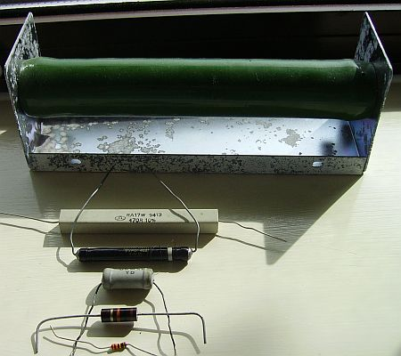 | 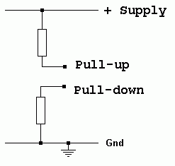

Working from the top down in the image above.
- Wire Wound: Designed to dissipate a lot of heat. Used in very high power situations. 100 Watt resistor.
- Wire Wound: Designed to dissipate heat. Used in high power situations. 10 Watt resistor.
- Wire Wound: Designed to dissipate less heat. Used in lower power situations. 5 Watt resistor.
- Wire Wound: Designed to dissipate less heat. Used in lower power situations. 5 Watt resistor.
- Carbon film: Cheap, not very stable over time, might generate circuit noise. Half Watt resistor.
- Metal Oxide: Slightly more expensive than carbon film, more stable over time, less circuit noise, Quarter Watt Resistor.
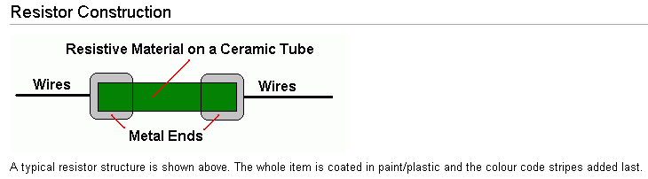

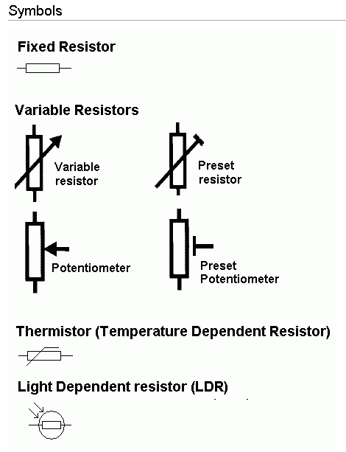 | Resistance …  - opposes the free flow of current.  - is like a thin water pipe or a narrow road or a narrow doorway opposing the free flow of people.  - is measured in Ohms.  - is related to the current and voltage by Ohm's law below.  - if a wire is replaced with a resistor, the current drops.  Definition of the Ohm  - If the resistance is one Ohm, a potential difference of one Volt will cause a current of one Amp to flow.  Ohm's Law  - At a given temperature, the potential difference or Voltage drop (V) across a resistor (R) is proportional to the current (I) flowing through it.

Zero Ohm Resistors
Zero ohm resistors exist. These are used instead of wires because robotic circuit board assembly machines are already able to work with standard resistor shapes. A whole new robot would be needed to work with wires so zero ohm resistors were invented.
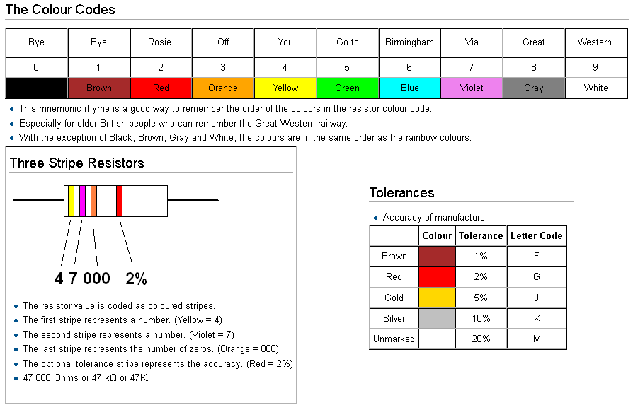

Calculations
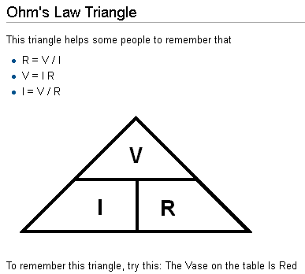

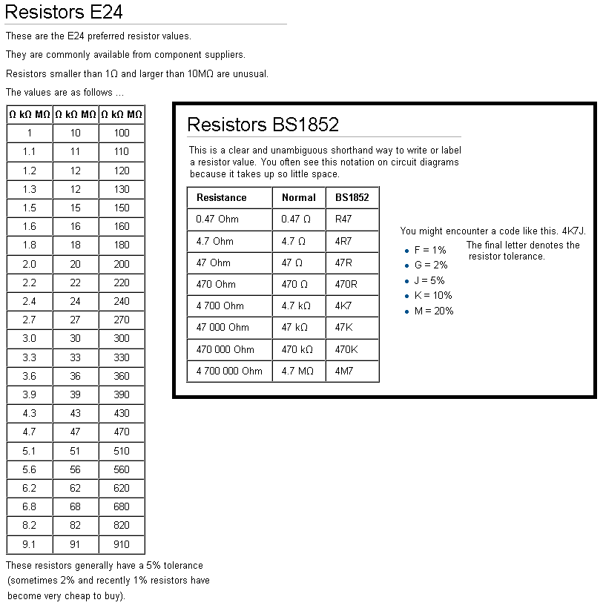

LDR  As the light gets brighter, the LDR resistance drops.  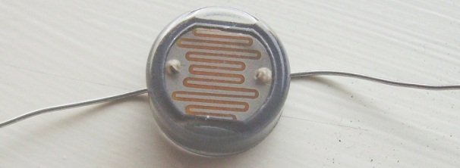  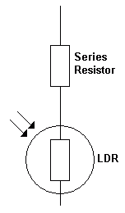 | Thermistor  As the temperature rises, the resistance drops.  