Page 14.1

Diode Properties
- Diodes allow current to flow in only one direction.
- Forward biased silicon diodes have 0.7 Volts (700mV) across them.
- Diodes protect circuits from incorrect polarity power connection.
- Electrons flow against the direction of the arrow.
- Diodes convert A.C. into D.C. by blocking one direction of current flow.
- Diodes protect semiconductors from damage caused by high back-emf voltages by allowing the inductor current to die away gradually.
- Zener diodes provide an accurate reference voltage.
- Light emitting diodes emit light. D'Oh!
- LASER diodes emit coherent monochromatic light.
- Photo-diodes are used as light sensors.
- PIN diodes are used as really sensitive and high speed light sensors.
- Lit LEDs have approximately 2 Volts across them.
- Diodes demodulate Amplitude Modulated radio signals.

Symbols
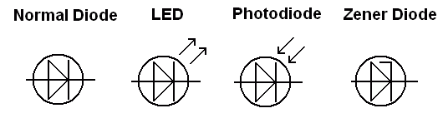

Diode Characteristics
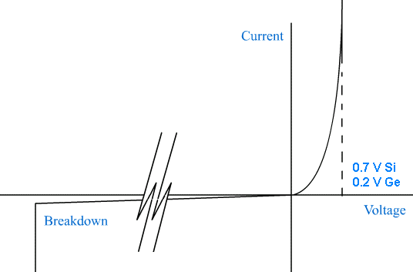

LEDs
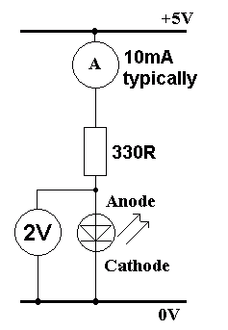 | LED Resistor Calculation – GCSE and AS  Work out the potential difference across the resistor = ( 5 – 2 ) Volts.  R = V / I  R = ( 5 – 2 ) / 0.01  R = 300 Ω  Use 330 Ω to allow a small safety margin.  The colour code of a 5% 330 Ω resistor is  Orange Orange Brown Gold

Zener Diodes
Zener diodes break down at a specified voltage in reverse bias.
They are most commonly used to provide an accurate reference voltage.

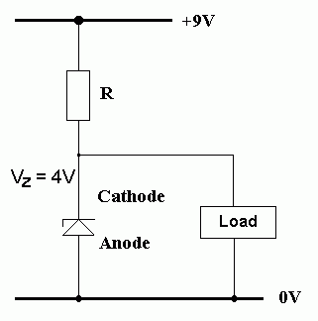 | Zener Diode Calculation – AS Only  - In this circuit assume the load takes a maximum current of 95 mA.  - For reliable operation, the Zener diode must take at least 5 mA.  - Under maximum load, the total current will be 100 mA.  - If the load current decreases, the Zener current increases by the exact same amount.  - With the load disconnected the Zener current rises to 100mA.  - This behaviour ensures that the voltage across the Zener diode remains constant.  If the Zener voltage is 4V and the supply voltage is 9V, the potential difference across R will be 5V.  Using Ohm's Law ...  R = V / I  R = ( 9 - 4 ) / (100 x 10-3)  R = 50Ω  The nearest suitable preferred value is 47Ω  51Ω would not be suitable because the Zener current might drop below 5mA.

Zener Diode Characteristics
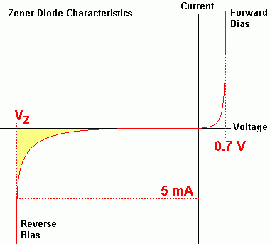 | In the shaded region, the Zener diode does not provide a correct reference voltage. At least 5 to 10 mA needs to flow before the correct reference voltage is reached.

Power Supplies – GCSE
Convert a 230 Volt alternating current into low voltage smooth direct current.
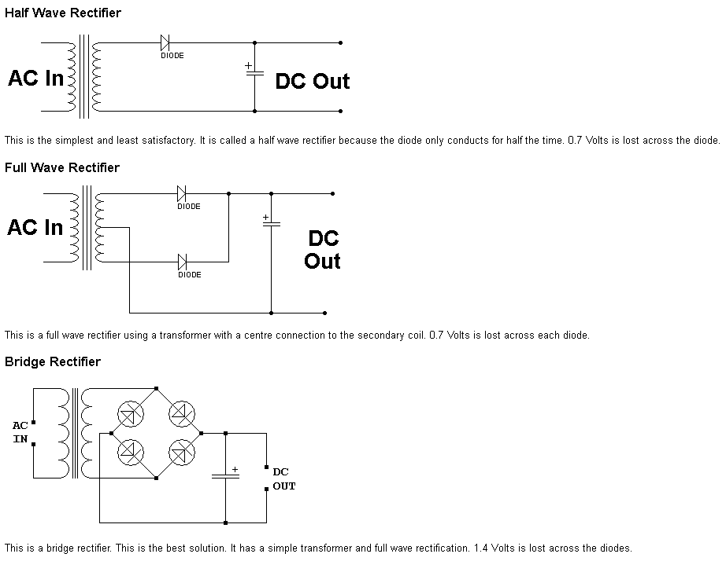

Blank page for class notes etc.

