Bipolar Transistor Page 16.1
A small BASE current controls a much larger EMITTER to COLLECTOR current.
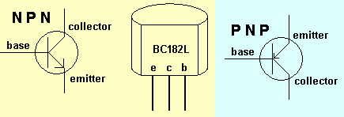
Current Gain = Ic / Ib
This value depends on the model of transistor and can be anything between about 10 and 400.
- Because a small current is controlling a much larger current, transistors can be used as amplifiers and switches.
- About 0.7 volts is needed before a current starts to flow in the base of the transistor.
- Under normal conditions the collector current is proportional to the base current.
- When the base voltage is too small and no current is flowing in the collector, the collector voltage is equal to the supply voltage. The transistor is said to be "CUT OFF".
- When the transistor is SATURATED (Ic is limited only by R2) the collector voltage is about 0.2V.

Switch Circuits
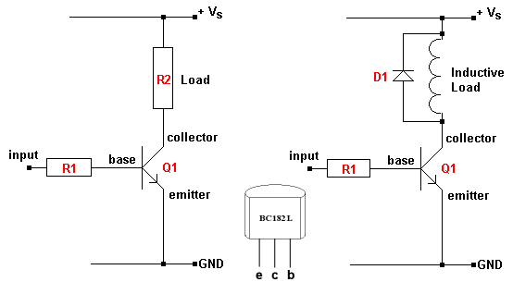

The BACK EMF diode protects the transistor from large voltages produced by the inductor by allowing the current to die away gradually. Sudden current changes produce damaging BACK EMFs.

