Operational Amplifiers Page 28.1

Ideal op-amp key facts ...

- The open loop gain is infinity.
- The input resistance is infinity.
- The output resistance is zero.
- The gain bandwidth product is infinity.

Comparator  If V1 > V2, the outpt is high.  If V1 < V2, the output is low. | 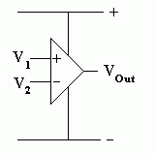  This circuit works because the op amp has a very high open loop gain. This means that tiny differences in the input voltage cause the op amp to saturate low or high.  Saturation occurs when the output is limited by the power supply voltage.
Non Inverting Amplifier  Gain = 1 + R_{f} / R1  Input resistance = Infinity / Very High | 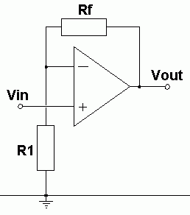

Page 28.2

Voltage Follower
The voltage gain is ONE.
The input resistance is INFINITY.

The current and power gain can be very large.

This circuit is used to drive a high current load without draining current from the input device.
Inverting Amplifier  Gain = - R_{f} / R₁  Don't forget the  minus sign!  Input resistance = R1 | 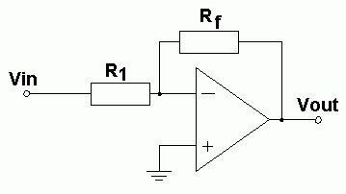  The inverting (-) op amp input is a virtual earth.  The op amp has a very high open loop gain so, if the op amp output is a few volts, the input (-) voltage must be a few microvolts. This input voltage is so close to zero it's called a virtual earth.
Summing Amplifier (Adding)  The inverting input is also a virtual earth.  This circuit is used to add input signals together. A studio mixer desk is a good example.  This circuit can also be used as a digital to analogue converter. Here are some example input resistances for a DAC ...  - R_{f} = 10k  - R₄ = 10k  - R₃ = 20k  - R₂ = 40k  - R₁ = 80k | 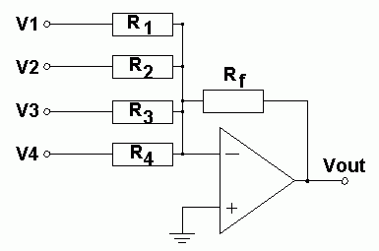  The input resistance of each input is equal to the input resistor.  V_{out} = - R_{f} (V₁/R₁ + V₂/R₂ + V₃/R₃ + V₄/R₄)
Page 28.3

Differential Amplifier (Subtracting)
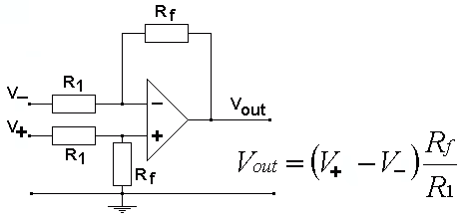
The input resistance is 2 R₁
If the two inputs are identical, after subtracting them, nothing is left so the output will be zero. This technique can be used to remove unwanted noise from the inputs.

Gain Bandwidth Product

This is a measure of how well the op-amp works at higher frequencies.

A typical value might be 1 Million Hertz or 1MHz.

There is a very simple mathematical relationship as follows.

In an open loop circuit an input frequency of ...
- 1Hz will be amplified 1 million times.
- 10Hz will be amplified 100 000 times.
- 100Hz will be amplified 10 000 times.
- 1000Hz will be amplified 1000 times.
- 10 000Hz will be amplified 100 times.
- 100 000Hz will be amplified 10 times.
- 1MHz will be amplified 1 times.

Input Frequency x Gain = 1Million.

So to calculate the gain at 500 Hz.

500 x GAIN = 1 Million.

GAIN = 1000000 / 500 = 2000

Page 28.4

