555 Monostable 30.1

Key Facts
- When triggered, the monostable produces a single accurately timed pulse. The output goes high for the timed period and then goes low again.
- The monostable has one stable state and one unstable state.
- In the circuit below, the 10k pull-up resistor pulls pin 2 high.
- Pressing the switch sends a LOW trigger pulse to pin 2.
- This turns on the output for a time T = 1.1 R C
- The duration of the output pulse is called its period.
- The reset switch can be pressed to end the timing earlier than normal.

How it Works - Exam Answer
- The timer starts when the trigger voltage drops below Vs / 3.#
- The output goes high and the discharge transistor turns off. Trigger pulses are ignored.
- C charges through R towards Vs.
- When the voltage across C reaches 2/3 of Vs, the timer resets. This takes 1.1 R C Seconds.
- The output goes low.
- The discharge transistor turns on and quickly discharges C to zero volts.

555 Monostable Circuit Diagram
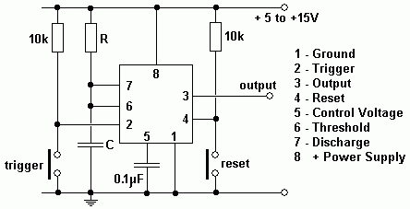

Pulse Time
The square wave output is high for the following period ...
T = 1.1 R C

555 Monostable Timing Diagram
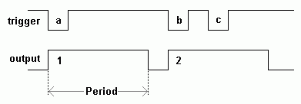
- The trigger pulse (a) turns on the output for a fixed time.
- Trigger pulse (b) turns the output on again.
- Trigger pulse (c) is IGNORED because the output is already on.

555 Astable

Key Facts
- This is an oscillator circuit providing a square wave output.
- The astable has zero stable states.
- Whichever state it is in (high or low), it will soon switch to the other state.
- The 555 chip CAN NOT drive a normal 8 Ohm loudspeaker.
- Piezoelectric sounders can be plugged straight in.
- A DC blocking capacitor may be needed with a resistor in series to limit the output current to less that 200 mA. 27 Ohms should be suitable for a 12 Volt circuit.
- The DC Blocking capacitor (if used) should have a low reactance at the operating frequency.
- The astable frequency depends on C1.

How it Works - Exam Answer
- If the output is high, the discharge transistor is off.
- C1 charges towards Vs through Ra and Rb until the threshold rises above 2/3 of the supply voltage.
- The output goes low and the discharge transistor turns on.
- C1 discharges towards 0 Volts through Rb until the threshold drops below 1/3 of the supply voltage.
- The output goes high again and the steps above repeat.
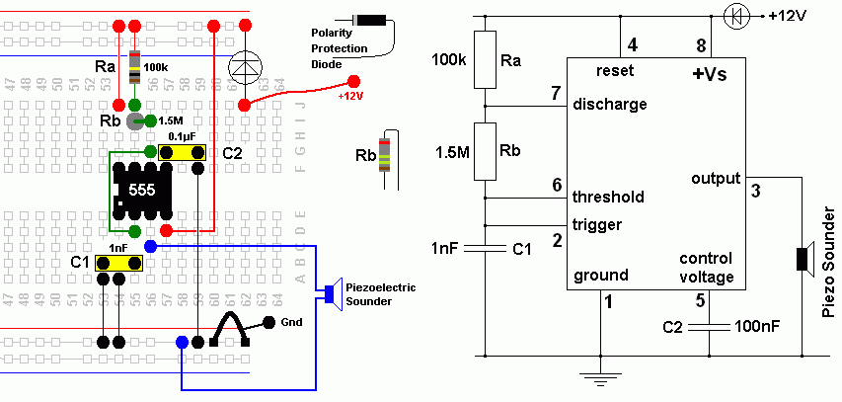
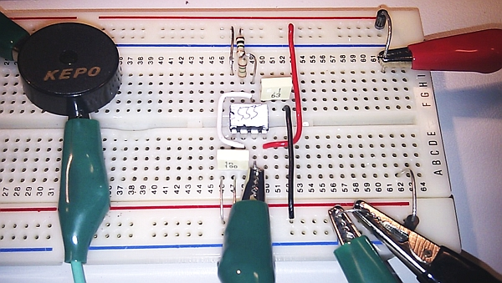

555 Astable Formulas

Frequency F = 1.44 / ((Ra + 2Rb) C1)
Low Time tL = 0.7 RbC1
High Time tH = 0.7 (Ra + Rb) C1

Symmetrical Square Wave
- To get a fairly symmetrical square wave, Ra should be a lot smaller then Rb.
- For adjustable frequencies, Rb can be a variable resistor.
- Try using an LDR for Rb. The frequency will depend on the light level.

Mark Space Ratio
The mark space ratio is a measure of the proportion of the time the output is high. For example if the output was high 80% of the time and low for 20% of the time, the mark space ratio would be 4 or 4:1
Mark Space Ratio = tH / tL

555 Timer Insides
Inside the 555 timer you will find ...
- Voltage Divider consisting of three 5kΩ resistors.
- These three 5k resistors may explain the name of this device.
- The threshold comparator goes high if the threshold input goes above 2/3 of the supply voltage.
- The trigger comparator goes high if the trigger input voltage drops below 1/3 of the supply voltage.
- Threshold Comparator.
- If the threshold input is greater than 2/3 Vs, the latch resets and the output goes low.
- The discharge transistor turns on and this pulls pin 7 (discharge) low too.
- Trigger comparator.
- If the trigger input is less than 1/3 Vs, the latch is set and the output goes high.
- The discharge transistor turns off and pin 7 (discharge) is controlled by components external to the 555 chip.
- Data Latch.
- This RS Flip Flop is set if the trigger input is less than 1/3 Vs.
- It is reset if the threshold input is greater than 2/3 Vs.
- Output Buffer.
- This is able to source or sink up to 200mA to the output.
- Reset (pin 4).
- If pin 4 is low, this resets or disables the timer and the other inputs have no effect.
- Discharge.
- This pin is held low by an NPN transistor used as a switch.
- This happens when the 555 output is low.
- If the 555 output is high, this transistor turns off and it has no effect on the rest of the circuit.
- (This arrangement is called "open collector").

The internal modules include ...
- The three 5k resistors used as voltage dividers
- Two Op' Amp' Comparators
- The RS Flip Flop / Bistable Latch
- The Output Buffer / Driver
- NPN Transistor used as a switch.

