Push Pull Amplifier Page 33.1

The Source Follower

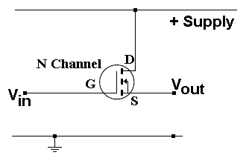
- The voltage gain is 1
- The power and current gain are very large.
- About two volts are lost between the gate and the source.
- G = Gate S = Source D = Drain
- Input resistance is close to infinity. Output resistance is low.
- The gate voltage needs to be above about 2V before the source voltage begins to rise.

Push Pull Amplifier

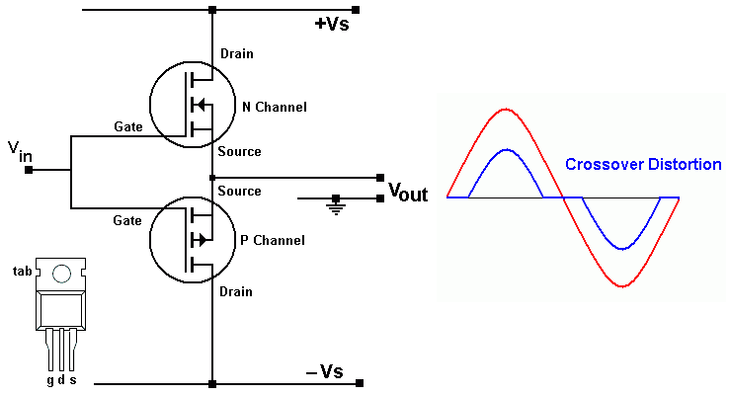

- This uses two source followers.
- The N Channel MOSFET amplifies the positive half of the input signal
- The P Channel MOSFET amplifies the negative half of the input signal
- If the input voltage is less than 2 V peak to peak, there will be no output.
- This results in serious cross-over distortion which is most obvious when the input is small.

Bias the MOSFETs to Reduce Cross Over Distortion
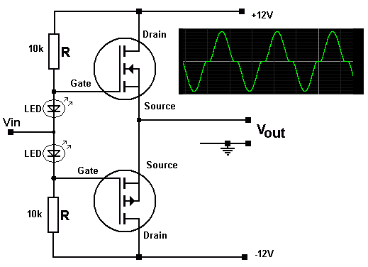
- The MOSFETS are biased.
- This means that the DC input voltage levels have been adjusted for better performance.
- The LEDs have about 2 volts across them.
- This raises the N Channel gate voltage to about +2 V. This MOSFET is much closer to turning on.
- This lowers the P Channel gate voltage to about -2 V. This MOSFET is much closer to turning on.
- The trace shows reduced cross over distortion.

Add Negative Feedback for even Better Performance
This circuit uses an op amp voltage follower.
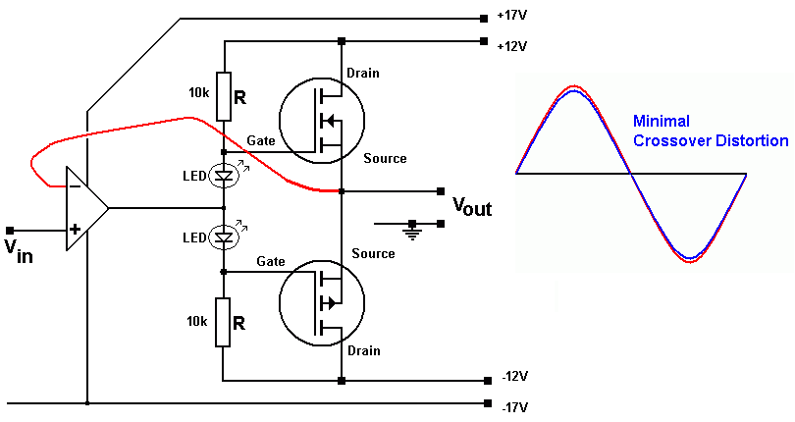
- This circuit has a voltage gain of 1 but a much higher power gain (power_out / power_in).
- The Op amp output potential will be just right to ensure that Vout = Vin
- Negative feedback is being used to correct for errors in the output.
- The operational amplifier is wired up as a voltage follower so Vout should track Vin exactly.
- Cross over distortion is minimised.
Push Pull Advantages
- Don't need a large coupling capacitor between the output and the speaker.
- In other types of amplifier, this capacitor limits the low frequency response (high pass filter).
- With no input signal, the quiescent current (idle current) is small so little energy is wasted.

Push Pull Disadvantages
- Cross Over Distortion
- MOSFETs have good high frequency properties.
- Usually this is an advantage but it makes it easy to build an oscillator capable of high power outputs. The oscillations are likely to be outside the range of human hearing but still able to overheat and destroy speakers, usually the tweeters. Careful design is needed.

Saturation, Clipping, Limiting
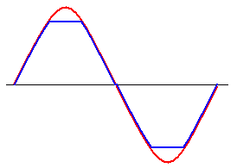
- The amplifier cannot produce output voltages that are larger than the power supply voltages.
- If the input is too big, the amplifier output will increase until it is nearly equal to the supply voltage.
- After that the output voltage cannot rise any more.
- The red trace above shows the input. The blue trace shows the amplifier output.
- The MOSFETs have saturated.
- The sine wave input is clipped.
- The amplifier output is limited (by the power supply voltage).

RMS Output Power
- The power supply is 20 Volts.
- An 8Ω speaker is being used.
- Decide whether to use 20V (ideal) or 18V (real life) in the calculation.
- If the exam question does not make it clear which one to use, just say whether you are doing the ideal or real life calculation.

Below, the ideal calculation is shown.

Vrms = 0.7 x Vpeak

Power = Vrms² / R

Power = (20 x 0.7)² / 8

Power = 24.5 Watts

This is the theoretical maximum power output.

Real Life Power Output

In real life, MOSFET push pull source followers are not perfect. The output will be lower than expected because ...

- The driver op-amp saturates a couple of volts below the power supply voltage.
- 2 or 3 volts are lost across the gate source junction in the MOSFETs.
- 0.7 to 4 Volts get lost in the biasing diodes depending on the type of diode used.
- The MOSFETs have Drain to Source resistance. Energy is lost here.

Points 1 to 3 above can be fixed by running the op-amp driver and MOSFET biasing on a higher power supply voltage. As these are low power circuits, this is not too expensive to do.

