Subsystems – Research – Specify – Build – Test – Evaluate

555 Monostable

Research

I used the www.ti.com/lit/ds/symlink/lm555.pdf data sheet to find out …

- The chip pinout  - The maximum safe power supply voltage  - The maximum safe chip current | 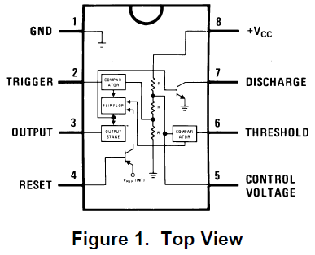

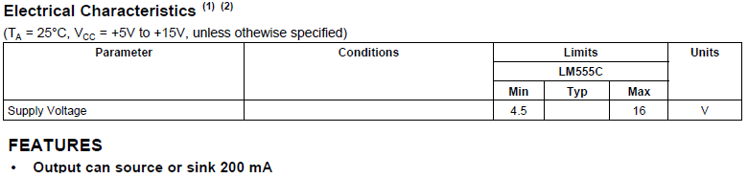

Specification and Test Planning

- Run on 4.5 to 16 Volts (The available power supply gives 12 to 15 Volts)
TEST: Use a multimeter to test the circuit on 12, 13, 14 and 15 Volts.
Check the timing at each of these voltages.
- Be triggered by a low pulse less than 1/3rd of the power supply.
TEST: Use a picoscope to measure the trigger pulse.
- Produce a pulse 1 to 1.2 seconds long.
TEST: Use a picoscope to measure this period.
- The chip current will be limited to less than 200 mA
TEST: Use a multimeter to measure the current.

Circuit Diagram and Calculations

T = 1.1 RC

Use 10 microfarads for the timing capacitor

Calculate for a 1.1 second pulse

R = 1.1 / ( 1.1 x 10 / 1000000) Ohms

R = 100 kΩ

The Finished Subsystem  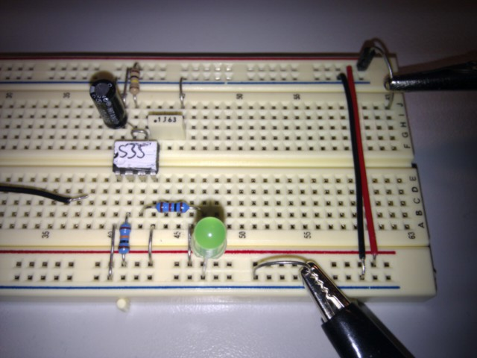 | HOW IT WORKS  - R2 is a pull up resistor. The trigger switch pulls the trigger voltage down to 0 V  - The timer starts when the trigger voltage drops below 1/3rd of the power supply.  - The output goes high and the discharge transistor turns off.  - C1 charges through R1 until the Threshold voltage reaches 2/3rd of the power supply voltage. This takes 1.1 R C Seconds.  - The output goes low and C1 is quickly discharged.

Testing

Test | Set Power  Supply | Input Pulse  Length | Output Pulse Length  1.1 s expected | Output Pulse Voltage | Subsystem Current
1 | 12 Volts | 0.1 s | 1.09 s | 12 V | 20 mA
2 | 13 Volts | 0.1 s | 1.1 s | 13 V | 21 mA
3 | 14 Volts | 0.1 s | 1.1 s | 14 V | 22 mA
4 | 15 Volts | 0.1 s | 1.12 s | 16 V | 24 mA

Test 1) Blue Input – Red Output  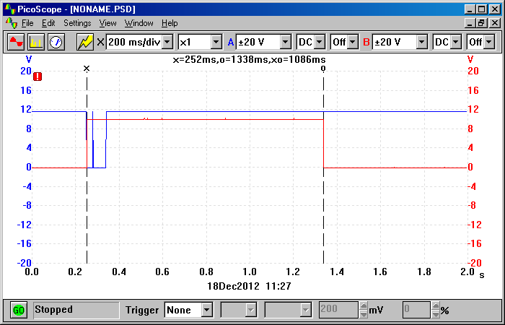  Input pulse length is about 0.1 seconds.  Output pulse length is 1.09 seconds.  Output pulse voltage is just under 12 V. | Test 2) Blue Input – Red Output  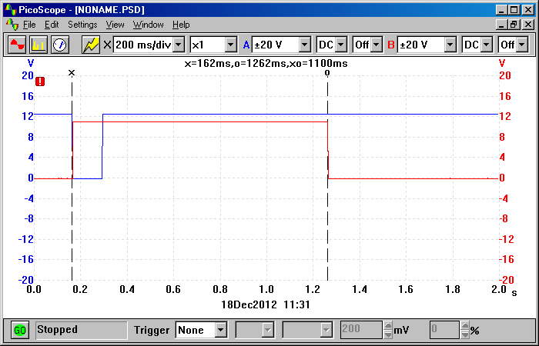  Input pulse length is about 0.1 seconds.  Output pulse length is 1.1 seconds.  Output pulse voltage is 13 V.
Test 3) Blue Input – Red Output  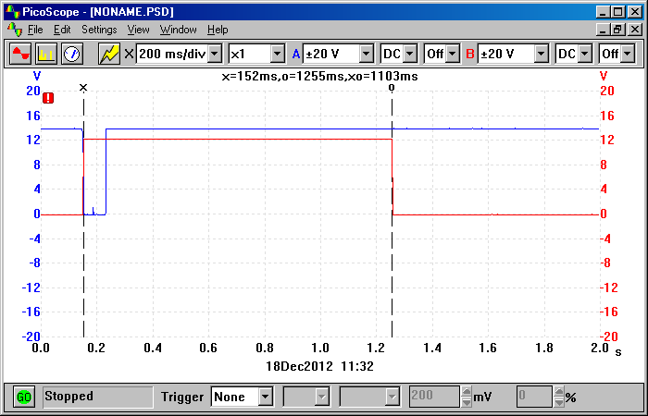  Input pulse length is about 0.1 seconds.  Output pulse length is 1.1 seconds.  Output pulse voltage is close to 14 V. | Test 4) Blue Input – Red Output  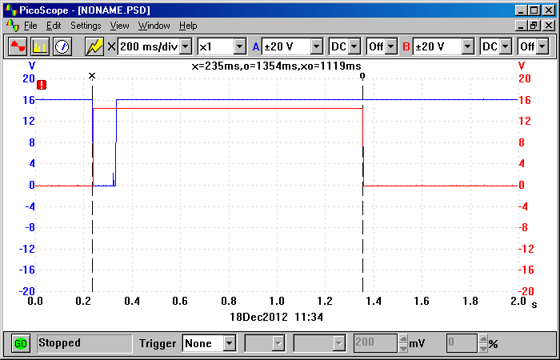  Input pulse length is about 0.1 seconds.  Output pulse length is 1.12 seconds.  Output pulse voltage is close to 16 V.

Evaluation of the Specification

- Run on 4.5 to 16 Volts (The available power supply gives 12 to 15 Volts)
Check the timing at each of these voltages.
SUCCESS: The timing was correct at each voltage to within +/- 2%.
- Be triggered by a low pulse less than 1/3rd of the power supply.
SUCCESS: The low trigger pulses did trigger the timer.
- Produce a pulse 1 to 1.2 seconds long.
SUCCESS: The pulse lengths were 1.1 +/- 2% Seconds.
- The chip current will be limited to less than 200 mA
SUCCESS: The chip current was between 20 and 24 mA. This was much less than the 200 mA limit.

Conclusion

The timer pulse length was correct within 2%.
The supply voltage had little effect on the pulse length.
Trigger pulses were about 0.1 seconds long and worked well.
The output voltage was similar to the supply voltage.

This is a 100% correct working circuit and it is fit for its purpose.

